IT2020 – Software Engineering

**Year 2, Semester II, 2022 Group Assignment**



**Online Transport System**

**Group Details**

**Batch: 9.1**

**SE/OOP Group Number: SE/OOP_MLB_WD_2022_S2_244**

|  |  |  |
| --- | --- | --- |
|  | **Student Registration Number** | **Student Name** |
| **1** | IT21378270 | Wimaladharma T. H. Y. B. |
| **2** | IT21379956 | Hettiarachchi V. E. |
| **3** | IT21387562 | Ekanayake E. M. A. M. |
| **4** | IT21377280 | Rajapaksha C. S. |

Introduction

ExpressGo is an online platform where you can Book vehicles to travel anywhere easily with Excellent service. ExpressGo provides you with the ability to schedule your trips, transport packages, and many other facilities. Passengers can get registered to the system by themselves. Registered customers can view the app and check the price by selecting relevant locations.

Passengers can log in to the system using their login credentials. It gets validated by the system. For incorrect credentials system ask the user to re-enter the correct credentials. If users can not remember the credentials, they can reset the password.

When booking vehicles, users have to select destination and pickup locations and the vehicle type. Then according to those details, the system calculates the price and displays it to the passenger. Passengers can add special notes as well.

You can do payments using a credit card, debit card, and cash. When you logged in to the system you can either add a card by navigating to payment or add the card details when you book trips. when passenger book a vehicle, they have to select the payment type. When a Passenger uses this System frequently, Company offers discounts. ExpressGo administration Sends emails that include codes called promo codes. Using that passengers can get discounts or their rides. If Passenger wants to do a cash payment, they have to select cash payment and Pay at the end of the trip.

Passengers can communicate with the driver and track the location of the driver who confirmed the ride. When a driver confirms the trip, a message is sent to the passenger about the confirmation. Drivers can edit their profiles such adding photos, editing the name, and editing phone numbers and email numbers. Also, they can edit the vehicle details. All these changes get saved to the system. Drivers can get a list of available trips.

A Registered passenger can view his/ her past trips(history). They can give feedback, rate, and give comments on their trips. If Passenger needs, they can contact customer care and get the service. All the modifications are approved by the admin. Admin manages promotions, profiles, and payments. Managers can manage salaries, manage policies, manage promotions, Generate reports and manage customer complaints using this system and take action.

When delivering the packages, the system allows you to select the item type and select drop locations. Here the unique ability is that you can add the receiver’s image. so that it will be much easier to deliver packages to the proper person. When this package delivery gets confirmed all the details get stored in the system. Passengers can rate the service. ExpressGo provides a much easier way to manage users day to day traveling activities with a good Service.



**Contents**

Use Case Diagram 4

IT21378270 | Wimaladharma T. H. Y. B 5

Use Case Scenario 5

Sequence Diagrams 8

Communication Diagrams 11

IT21379956 | Hettiarachchi V.E 13

Use Case Scenarios 13

Sequence Diagrams 15

Communication Diagrams 17

IT21387562 | Ekanayake E. M. A. M 19

Use Case Scenario 19

Sequence Diagram 21

Communication Diagram 22

IT21377280 | Rajapaksha C. S. 23

Use Case Scenario 23

Sequence Diagram 25

Communication Diagram 26

Contributions 27

# Use Case Diagram

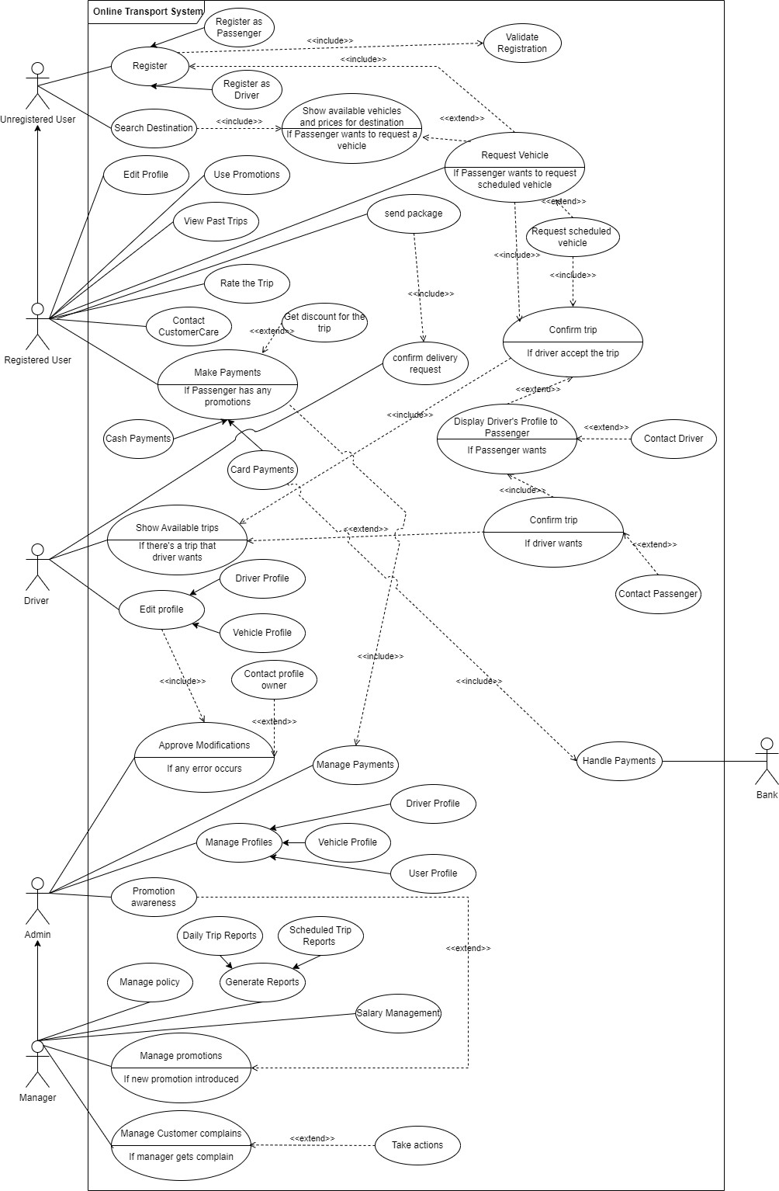

For original image UseCaseDiagram

# IT21378270 | Wimaladharma T. H. Y. B.

## Use Case Scenario

User login

|  |  |  |
| --- | --- | --- |
| Name | User (Driver) login | |
| Summary | User login to the system | |
| Priority | 1 | |
| Pre-conditions | The user must be registered with the system | |
| Post-conditions | The user can log in to his account | |
| Primary Actors(s) | Passenger, Driver | |
| Secondary Actor(s) | - | |
| Main Scenario | **Step** | **Action** |
| 1 | The user navigates to the login interface of the system. |
| 2 | The user enters his login credentials (username & password). |
| 3 | The user can navigate to the “Forget Password” option and click on it. |
| 4 | The user has to enter a registered Email address to recover the password. |
| 5 | The user types new password and proceeds. |
| Extensions | **Step** | **Branching action** |
| 2. a | The system checks whether entered username and password are valid or invalid. |
| 2. b | If not, ask to re-enter username/password, maximum up to 5 times including current attempt. |
| 4. a | System check whether entered email is in user records and validate it. |
| 4. b | If it is in, send password reset link to recover password. |
| 4. c | If not, system ask to enter valid email until enter a valid email. |
| 5. a | The system checks whether the new password is strong or not. |
| 5. b | If not, ask to re-enter a new password until type a strong password. |

Driver edits profile

|  |  |  |
| --- | --- | --- |
| Name | Driver edits profile | |
| Summary | Driver edits driver (user) profile and vehicle profile | |
| Priority | 2 | |
| Pre-conditions | The driver (user) must log into the system | |
| Post-conditions | The driver can edit his profile and vehicle profile | |
| Primary Actors(s) | Driver | |
| Secondary Actor(s) | Admin | |
| Main Scenario | **Step** | **Action** |
| 1 | Driver login to the system using his login credentials. |
| 2 | Driver navigates to the Driver UI. |
| 3 | Go to the navigation menu. |
| 4 | The user selects “Driver Profile”. |
| 5 | Navigate to the Driver profile and click on “Edit driver”. |
| 6 | The user clicks on “Edit profile photo”. |
| 7 | System pop-out a window to select a photo to upload as a profile photo. |
| 8 | System display “photo uploaded”. |
| 9 | The user clicks on the First name and changes it. |
| 10 | The user clicks on the Last Name and changes it. |
| 11 | The user clicks on the phone number and enters the phone number with the country code and clicks “Add”. |
| 12 | The user enters the verification code sent to the mobile phone. |
| 13 | The system display “Phone Number updated”. |
| 14 | The user clicks on Email and enters a new email address and clicks “set”. |
| 15 | The user enters the verification code sent to the provided email address. |
| 16 | System display “Email Updated”. |
| 17 | The user clicks on “Save Changes”. |
| 18 | System display “Updated Successfully”. |
| 19 | The user selects “Vehicle Profile”. |
| 20 | Navigate to the vehicle profile and select “Update Vehicle Info”. |

|  |  |  |
| --- | --- | --- |
|  | 21 | The user clicks on the “Upload Documents” option and uploads relevant documents. |
|  | 22 | The user clicks on “Send to approval”. |
| 23 | The system displays “Documents approved”. |
| 24 | The user logs out of the system. |
| Extensions | **Step** | **Branching action** |
| 1. a | The system checks whether entered login credentials are valid or invalid. |
| 1. b | If the entered login credentials are invalid, the system will show an error message and ask to re-enter logging credentials (maximum up to 5 times including the current attempt). |
| 1. c | The system displays the “Forget password” option to recover the password. |
| 7. a | The system checks whether the photo size is less than or equal to 5MB and photo format is JPG, PNG, or JPEG. |
| 7. b | If not system display “Invalid photo format or photo size exceeds 5MB”. |
| 11. a | The system checks whether the phone number format is correct. |
| 11. b | The system sends a verification code to the given mobile number. |
| 12. a | The system checks whether the code is valid or invalid. |
| 12. b | If not valid ask to re-enter the code. |
| 14. a | The system checks whether the email address is a valid one. |
| 14. b | If not ask to re-enter a valid email address. |
| 14. c | The system sends a verification code to the email address. |
| 15. a | The system checks whether entered code is valid or invalid. |
| 15. b | If not ask to re-enter the code. |
| 17. a | Changes forward to Admin for approving changes/modifications. |
| 17. b | If not approved by the admin, display “Please try again”. |
| 21. a | The system checks whether the uploaded document size is less than 10MB and in PDF format. |
| 21. b | If not ask to upload again. |
| 22. a | Admin checks whether uploaded documents are valid/invalid. |
| 22. b | If invalid, ask to re-upload the documents. |

## Sequence Diagrams

User login

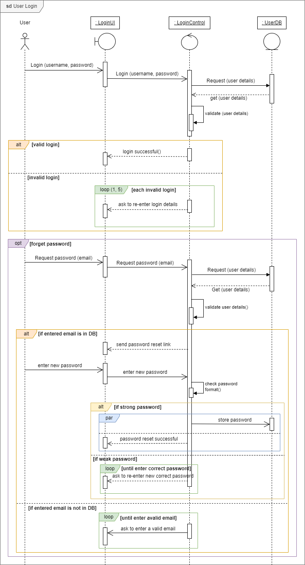

For original image SD_UserLogin

Enter OTP & validation

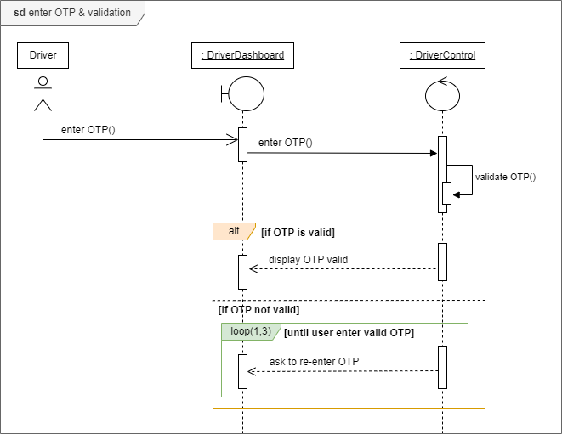

Driver updates profile

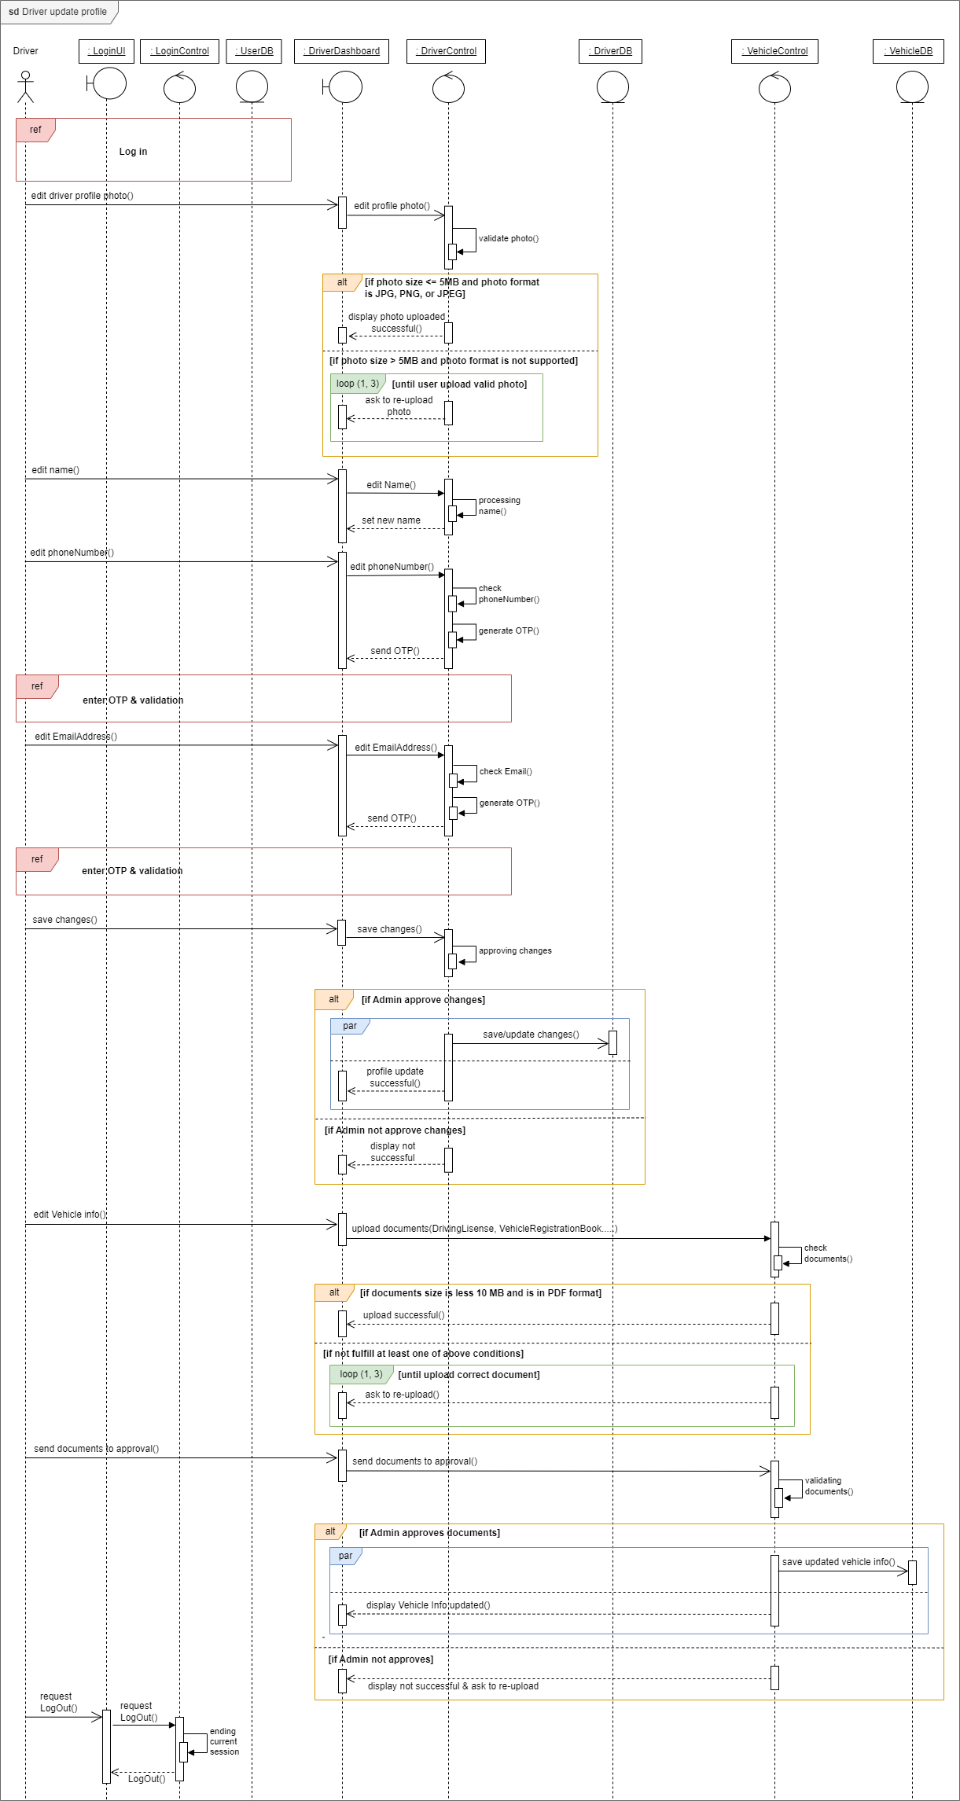

For original image SD_driverUpdatesProfile

## Communication Diagrams

OTP enter & validation

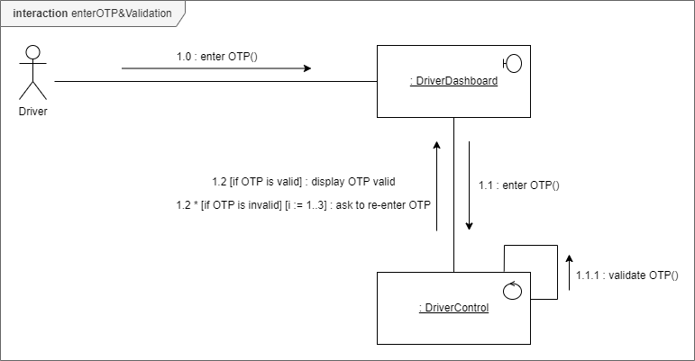

For original image COM_otpValidation

Driver updates profile

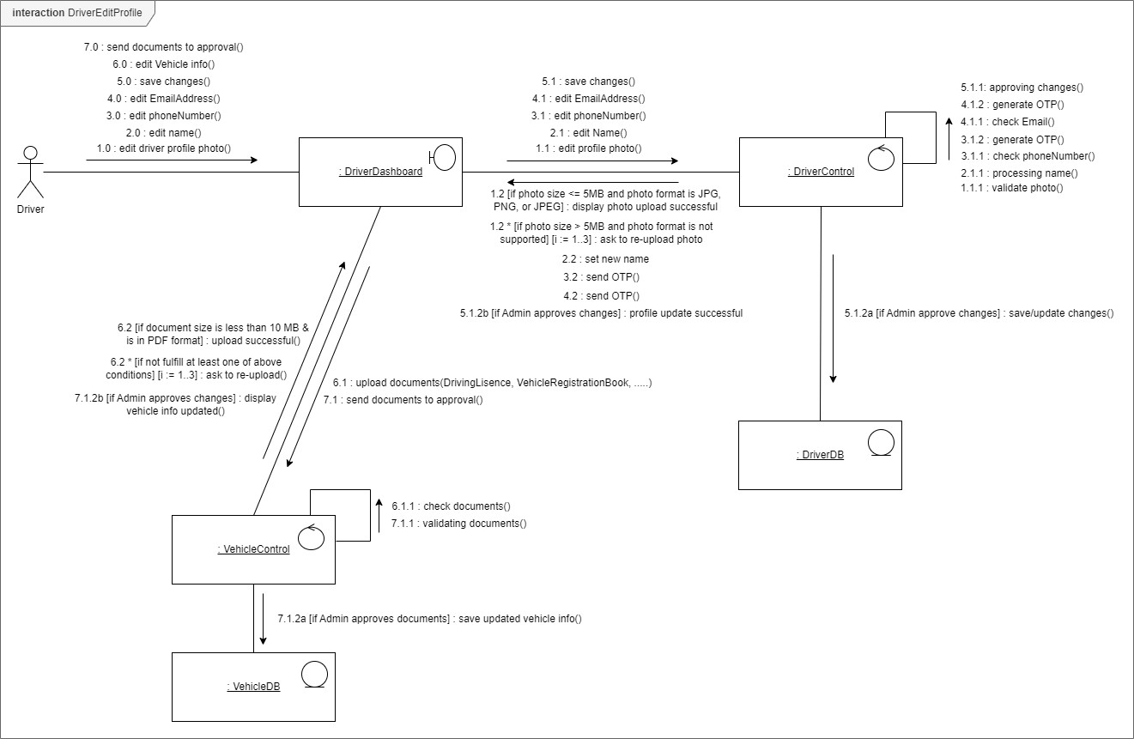

For original image COM_updateProfile

# IT21379956 | Hettiarachchi V.E.

## Use Case Scenarios

Add Card details

|  |  |  |
| --- | --- | --- |
| Name | Add Card Payment details | |
| Summary | Adding card payment details | |
| Priority | 3 | |
| Pre-conditions | Must login to the system as a registered user. | |
| Post-conditions | Payment card detail confirm. | |
| Primary Actors(s) | Passenger | |
| Trigger | Add details | |
| Main Scenario | **Step** | **Action** |
| 1 | Login to the website using credentials. |
| 2 | Go to ‘Payments’ page through the navigation bar |
| 3 | Select ‘Add Payment method’. |
| 4 | Select ‘Add new debit card or Credit card’. |
| 5 | Select the ‘Card type’. |
| 6 | Fill the card details. |
| 7 | Press ‘Save and Confirm’ after filling the details. |
| 8 | Enter received OTP number. |
| 9 | Validate OTP |
| 10 | Press ‘Submit’ to save entered card details. |
| 11 | Get Add card payment method success alert. |
| 12 | Meanwhile System saves the card details in passenger profile. |
| Extensions | **Step** | **Branching action** |
| 01a | Display error message if the entered login credentials are wrong. |
| 02b | Passenger can add card details when booking also. |
| 06a | If the card number is incorrect, show an invalid error message. |
| 09a | Display an error message if the entered OTP number is invalid. |
| 09b | Allow the passenger to enter the OTP number again. |

Payment

|  |  |  |
| --- | --- | --- |
| Name | Payment | |
| Summary | Pay for the trip | |
| Priority | 4 | |
| Pre-conditions | Trip must be completed. | |
| Post-conditions | Payment completed. | |
| Primary Actors(s) | Passenger | |
| Trigger | To complete the booking process | |
| Main Scenario | **Step** | **Action** |
| 1 | Trip get confirmed by the passenger. |
| 2 | Display the amount to be paid for the ride. |
| 3 | Select ‘Pay’ button and it will direct you to the Payment page. |
| 4 | Select a payment method from cash, credit or debit card payment. |
| 5 | If card payment was selected, allow user to select the saved card. |
| 6 | System validates card details. |
| 7 | When passengers use the app frequently, System sends emails containing promocodes (discounts). |
| 8 | If passenger needs to use the promocode, they can enter the code by selecting ‘promocode’ as an optional action. |
| 9 | System will allow to add the promocode in the provided space. |
| 10 | Press ‘Continue’. |
| 11 | The system validates the promocode. |
| 12 | The system calculates the final value by reducing the discount. |
| 13 | Return to the booking pages to continue further. |
| Extensions | **Step** | **Branching action** |
| 4a | If the passenger wants cash payment, he/she should select the ‘cash’ button. |
| 4b | The system will direct the passenger to the Booking page to continue further. |
| 4c | At the end of the ride, passenger should hand over cash to the Driver. |
| 5a | If the user wants to add a new card, select ‘add payment method’ and fill details |
| 9a | If entered promo code is incorrect, show invalid message. |
| 9b | Allow passenger to re-enter it (3 times). |

## Sequence Diagrams

Add Card Details

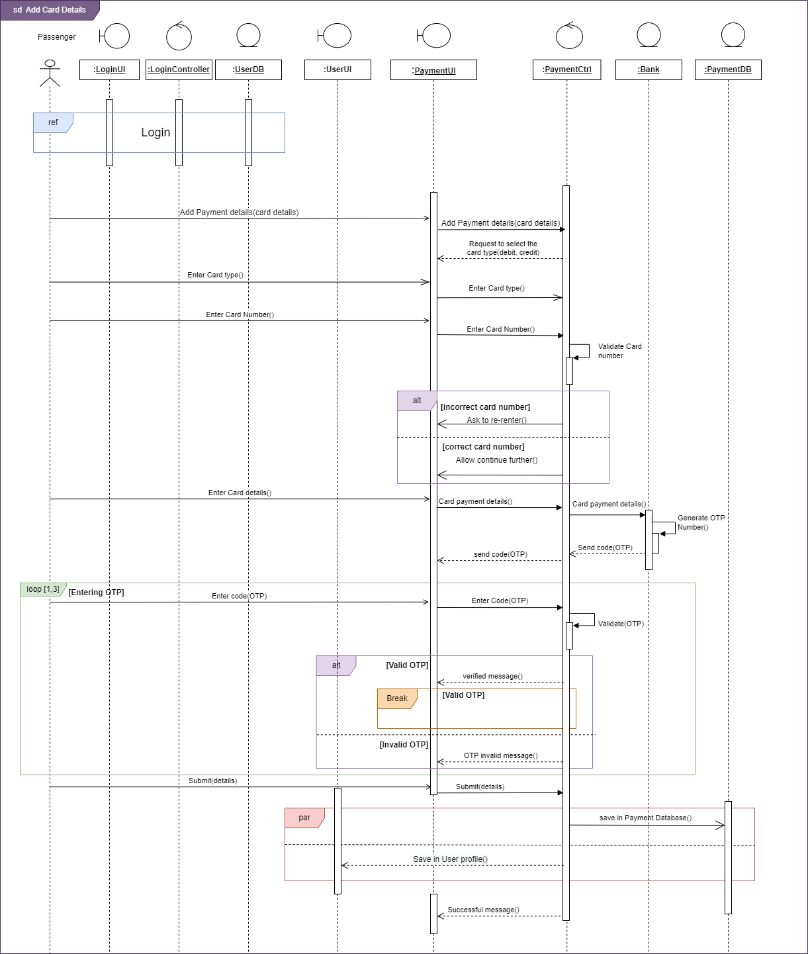

For original image SD_addCardDetails

Payment

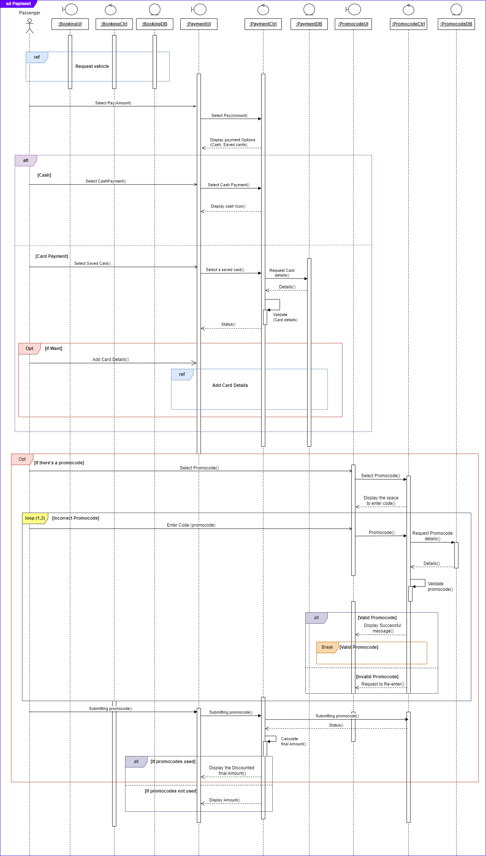

For original image SD_Payment

## Communication Diagrams

Add Card Details

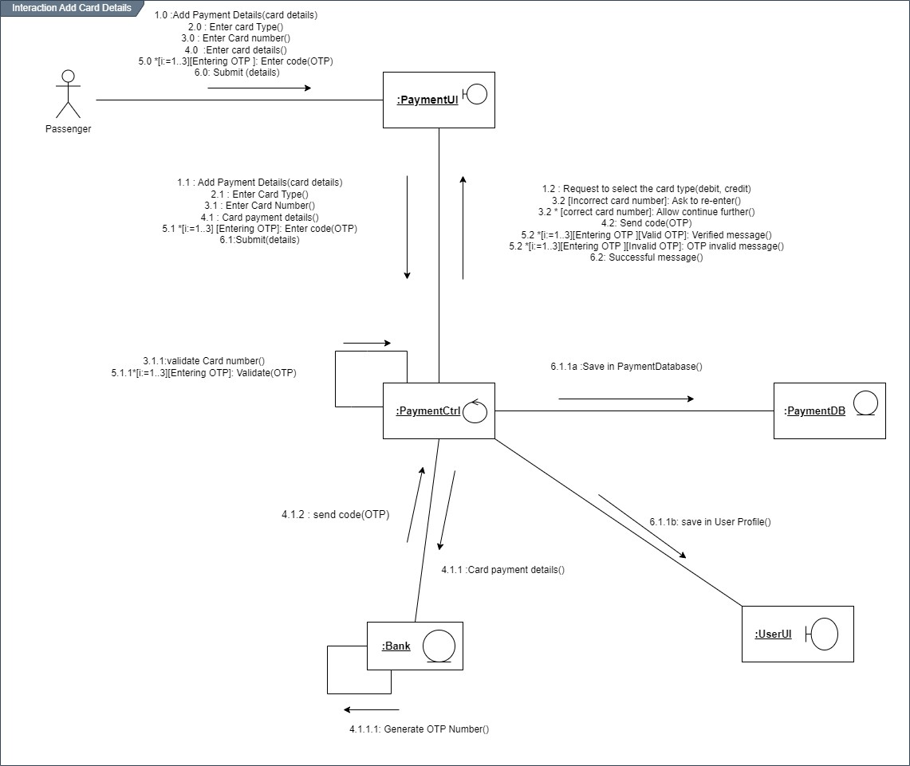

For original image CD_addCardDetails

Payment

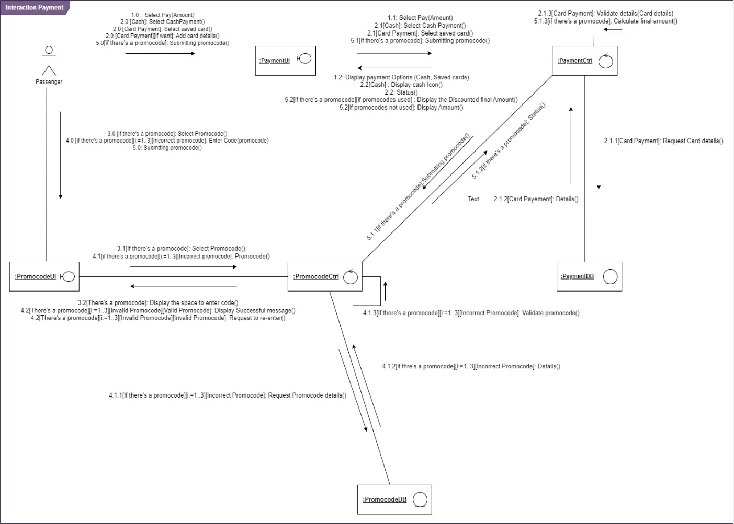

For original image CD_Payment

# IT21387562 | Ekanayake E. M. A. M.

## Use Case Scenario

Request Vehicle

|  |  |  |
| --- | --- | --- |
| Name | Request Vehicle | |
| Summary | Passenger can book a vehicle according to their needs. | |
| Priority | 5 | |
| Pre-conditions | Passenger must be registered in the system. | |
| Post-conditions | Passenger can reach their desired destination by their desired vehicle. | |
| Primary Actors(s) | Passenger | |
| Main Scenario | **Step** | **Action** |
| 1 | Passenger logs into the system. |
| 2 | Passenger navigates to the vehicle booking section. |
| 3 | Passenger enters the destination address. |
| 4 | The passenger enters the pickup address. |
| 5 | The system shows the types of vehicles available and the total cost of the ride. |
| 6 | The passenger selects the type of vehicle he wants. |
| 7 | System checks if the selected vehicle type is available at the pickup address. |
| 8 | The system shows the available vehicles on the map. |
| 9 | Passenger tap “Book Vehicle” and confirm the trip. |
| 10 | A passenger waits for the request to be accepted by a driver. |
| 11 | The system shows the information of the accepted driver. |
| 12 | A passenger waits for the driver to arrive. |
| 13 | The system shows the driver’s location on the map. |
| 14 | The system notifies the passenger when the driver is close to the pickup address. |
| Extensions | **Step** | **Branching action** |
| 1.a | The system notifies that the user entered an invalid username. |
| 1.a.1 | The system displays a “Re-enter username” message. |
| 1.b | The system notifies that the user entered an invalid password |
| 1.b.1 | The system displays the “Re-enter password” option. |
| 1.b.2 | The system displays the “Forget password” option |

|  |  |  |
| --- | --- | --- |
|  | 1.c | System display exits option. |
| 2.a | If passenger wants he /she can book a scheduled trip. |
| 2.a.1 | Enter the trip date and the pickup time. |
| 3.a | System fails to identify the extract destination address. |
| 4.a | System fails to identify the extract pickup address. |
| 7.a | System recognizes that the type of vehicle selected by the passenger is not available at this time. |
| 7.a.1 | System asks the passenger to select another vehicle type. |
| 8.a | System fails to load the map. |
| 10.a | Driver does not accept the passenger’s request. |
| 10.a.1 | System sends the request to another driver. |
| 11.a | System fails to display the information of the driver. |
| 13.a | System fails to display the driver’s location on the map. |
| 13.a.1 | Passenger can contact the driver. |
| 14.a | Driver fails to find the pickup address. |
| 14.a.1 | Passenger can make a note about the pickup address, at the time of entering the pickup address. |

## Sequence Diagram

Request a Vehicle

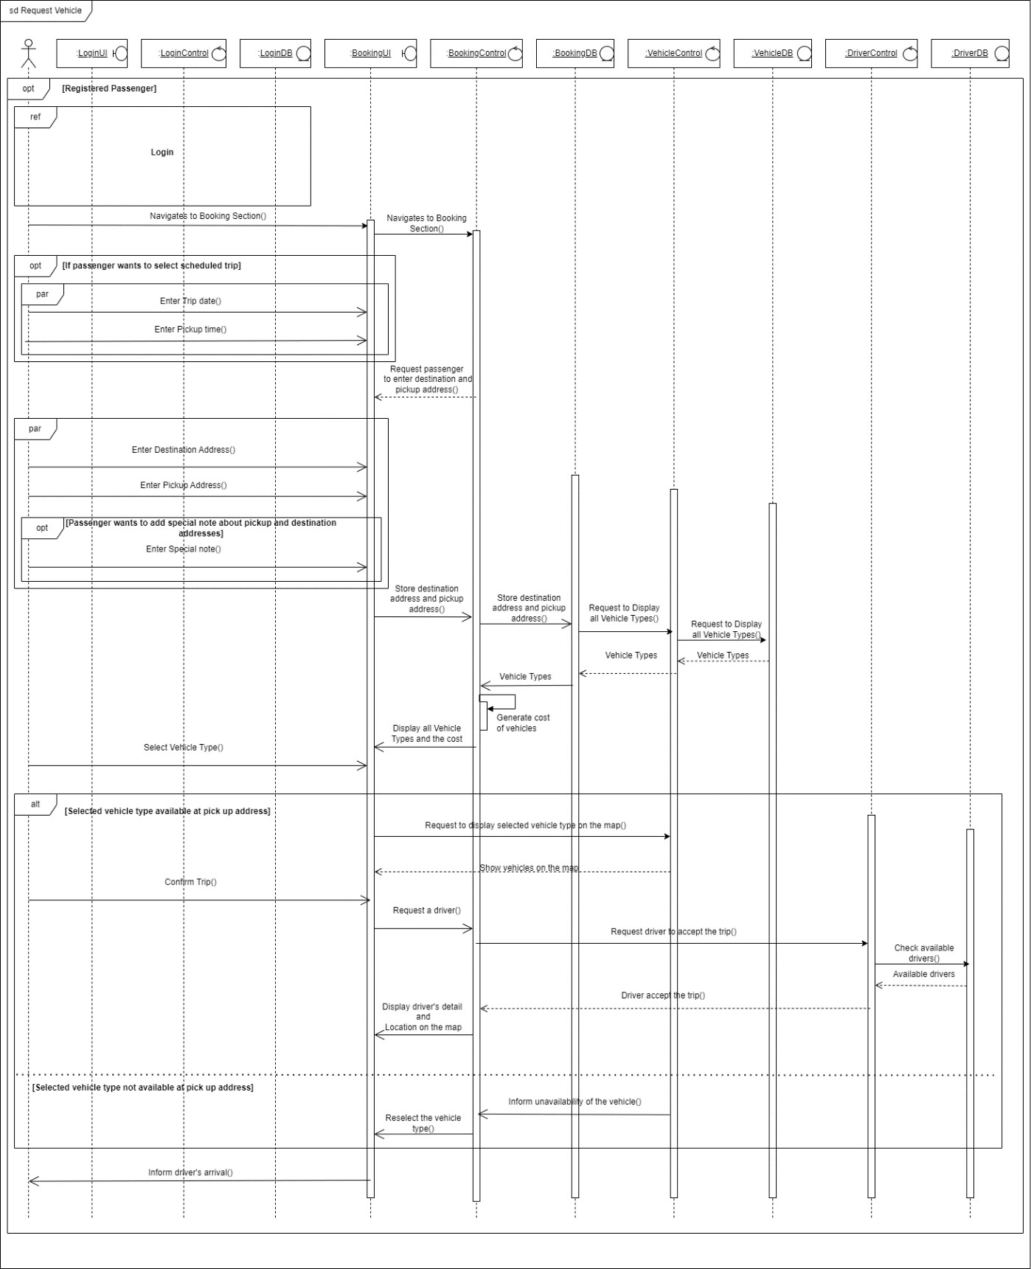

For original image SD_requestVehicle

## Communication Diagram

Request a Vehicle

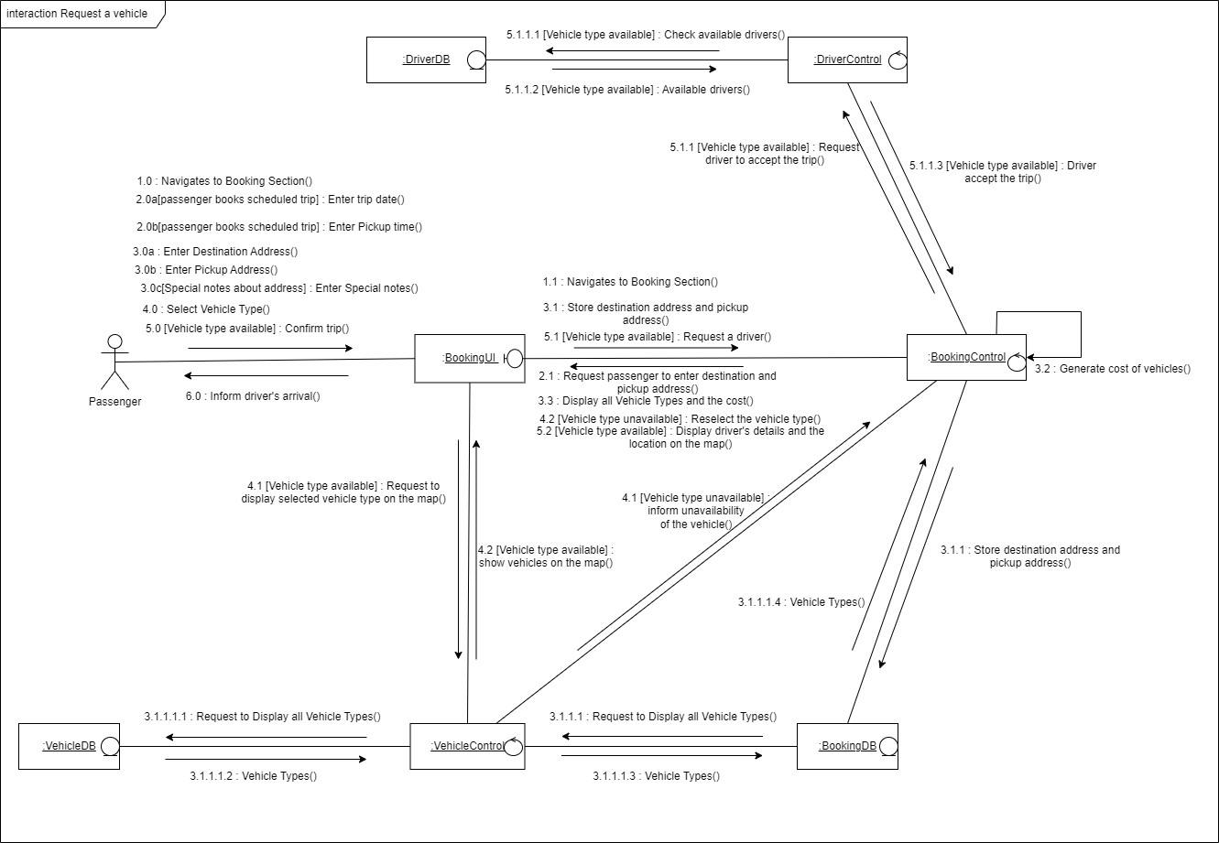

For original image CD_requestVehicle

# IT21377280 | Rajapaksha C. S.

## Use Case Scenario

Send Packages

|  |  |  |
| --- | --- | --- |
| Name | Send Packages | |
| Summary | Send Packages | |
| Priority | 6 | |
| Pre-conditions | User has logged to the system | |
| Post-conditions | User can check status of send package | |
| Primary Actors(s) | Registered user | |
| Trigger | The user chooses to send the package | |
| Main Scenario | **Step** | **Action** |
| 1 | Visit the website. |
| 2 | Login to the website. |
| 3 | The user should select the ‘Package’ button. |
| 4 | The user should choose ‘Send’ or ‘Receive’. |
| 5 | If the user select ‘Send’, System asks item type. |
| 6 | The sender should select one or more items type or enter the type of item. |
| 7 | Then, Sender clicks on the ‘Next’ button. |
| 8 | The sender should add one or less than 3 package reserved locations and delivery contact. |
| 9 | A sender can upload a photo of the receiver as optional. |
| 10 | The sender clicks the ‘Next’ button. |
| 11 | The sender should select the pickup location. |
| 12 | The sender clicks the ‘Done’ button. |
| 13 | The system chooses the most suitable vehicle type. |
| 14 | System checks available vehicles that choose. |
| 15 | The system shows the requested delivery to Drivers. |
| 16 | Meanwhile, System shows available vehicles to the user. |
| 17 | If one of the drivers confirms the delivery, System sends a notification to the user as “Delivery was confirmed by Driver”. |
| 19 | Meanwhile, the User can track the Driver. |
| 20 | If Sender does the payment, Sender can do a cash or card payment of the amount before starting the delivery. |

|  |  |  |
| --- | --- | --- |
|  | 21 | After completing the delivery, sender can rate and add comment to driver profile. |
| Extensions | **Step** | **Branching action** |
| 15a | If one of the drivers does not confirm delivery, System informs it to sender. |
| 16a | If sender wants to cancel the deliver, sender should pay delivery charge for driver. |
| 17a | If Sender does not the payment, receiver should do cash payment. |
| Open issues | 1 | Driver should confirm deliver. |

Accept package delivery

|  |  |  |
| --- | --- | --- |
| Name | Accept deliver the package | |
| Summary | Accept deliver the package | |
| Priority | 7 | |
| Pre-conditions | The driver has logged into the system | |
| Post-conditions | The driver can check the status of the delivery. | |
| Primary Actors(s) | Driver | |
| Trigger | The driver confirms the delivery. | |
| Main Scenario | **Step** | **Action** |
| 1 | Visit the website. |
| 2 | Driver checks available delivery. |
| 3 | The system shows available delivery with prices and destinations. |
| 4 | If the driver wants to confirm the trip, click the ‘Accept’ button. |
| 5 | If a driver accepts the requests, System sends a notification to the user as “Trip was confirmed by driver”. |
| 6 | If the package sender contacts the Driver, he should respond. |
| 7 | The driver can get payment from the sender or receiver based on the sender’s decision. |
| 8 | After completing the delivery, the driver can see the rate and comments from the sender. |
| Extensions | **Step** | **Branching action** |
| 4a | If the driver wants to cancel the delivery, click ‘Reject’ button. |
| 4b | If driver canceled the deliver, system will notify other drivers about that trip. |
| Open issues | 1 | Sender should not cancel the deliver. |

## Sequence Diagram

Package delivery

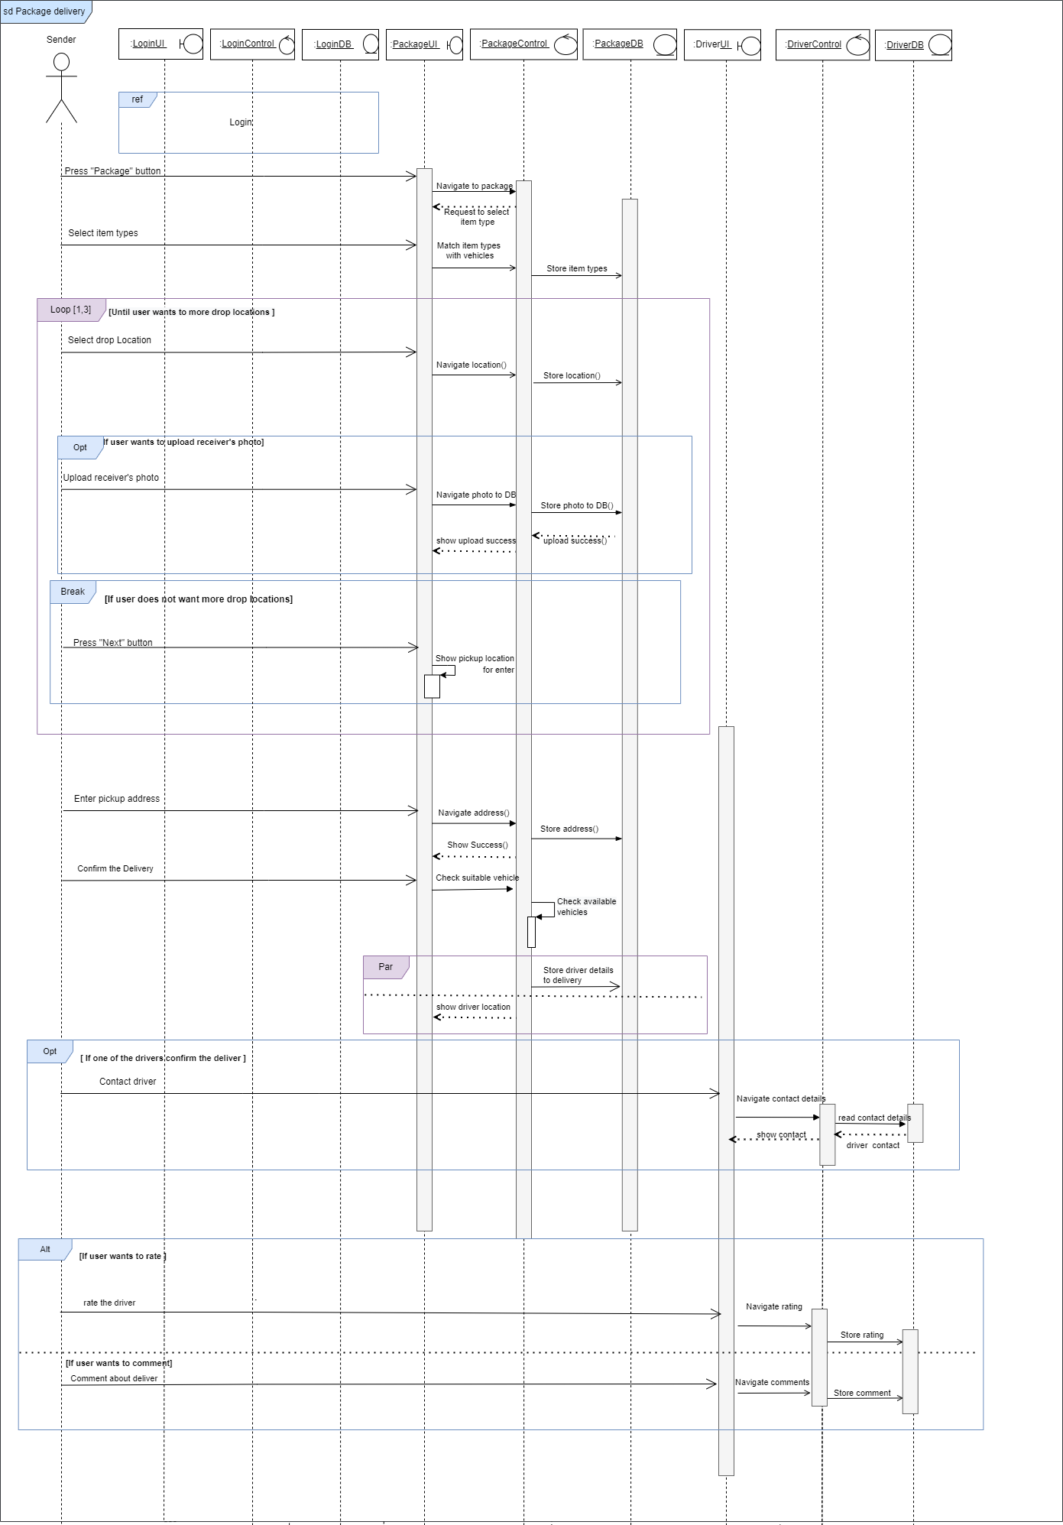

For original image SD_packageDelivery

## Communication Diagram

Package delivery

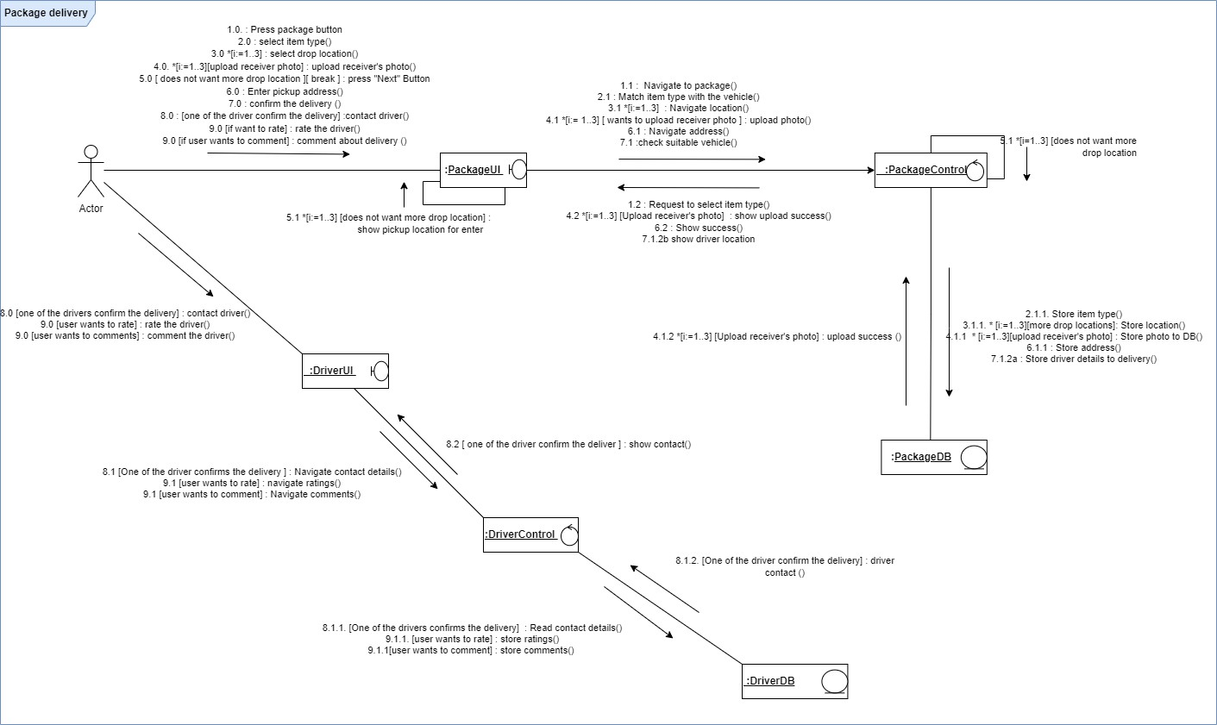

For original image CD_packageDelivery

# Contributions

|  |  |  |
| --- | --- | --- |
| Registration No. | Name | Function(s) |
| IT21378270 | Wimaladharma T. H. Y. B. | User login  Driver edits profile Enter OTP & validation |
| IT21379956 | Hettiarachchi V. E. | Add card details Payment |
| IT21387562 | Ekanayake E. M. A. M. | Request a Vehicle Schedule a book |
| IT21377280 | Rajapaksha C. S. | Send packages Package delivery |